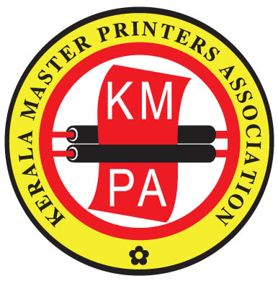
presents
Saturday
22nd February, 2025
Radisson Blu
Kochi

9th Edition

Registration Form

I / We, would like to attend the “Print & Beyond Seminar 2025” on 22.02.2025 as a delegate.
An amount of Rs. ......................... is sent herewith by Cash / Cheque / DD No. ...........................................
dated ............................................ / online transaction with UTR No. .............................................................
Bank ............................................................................................................... dated ........................................
in favour of Kerala Master Printers Association towards registration fee.
Organization:
Address:
City/State: |  | Postal Code:
Phone:
Email :

Following representative(s) from our Organization would like to register for the seminar:

Name in Full | Designation | Telephone/ Mobile | E-mail

Registration fee per delegate: For KMPA members Rs. 3000/- (including 18% GST)
For non-members Rs. 3540/- (including 18% GST)
Scan QR Code to pay 
For online payments the bank details are given below:
Name of Account - Kerala Master Printers Association;
Name of Bank - State Bank of India; Branch - Kaloor, Ernakulam;
Account Number - 30477931783; IFS Code - SBIN0008621
Please return the filled up Registration Form by mail to
kmpacochin@gmail.com

KERALA MASTER PRINTERS ASSOCIATION
Casa Grante Building, Desabhimani Junction, Kaloor, Cochin - 682 017
Tel: 0484-4042715 e-mail: kmpacochin@gmail.com

